Red & White Dairy Cattle Association
Ambassador Program

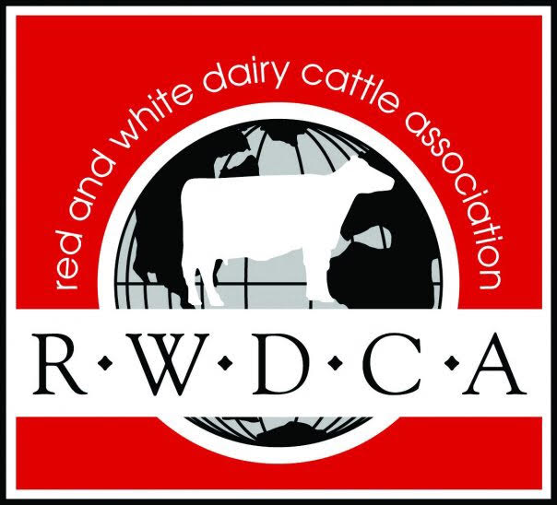

Rules
- Candidates must be a Junior member in good standing with the Red & White Dairy Cattle Association.
- Candidates must be between the ages of 16-20 by January 1st of 2024.
- Candidates must enter an official application signed by their parent or guardian by the deadline.
- Candidates will be judged by a committee on general intelligence, speaking ability, knowledge, and experience within the Red & White Dairy breed. As well as goals and plans for promotion of the Red & White Dairy cattle association.
- Candidates must sign a National Red and White Ambassador code of conduct form.

- The ambassadors’ responsibilities include:
  - Promoting the RWDCA and the breed on social media and at events
  - Attend Board meetings via Zoom, World Dairy Expo, National Red and White sale, and other breed meetings that may arise throughout the year. A full Calendar of events will be provided once the applicant is selected and will depend on where they are located.
  - Create social media content for all social media outlets to engage both adult and junior membership.

The 2024-2025 Ambassador reign will run from
July 1st, 2024 to June 30th, 2025

National Red & White Ambassador Application Form
Application deadline: May 15, 2024
Applications should be printed or typed and then emailed to rwdcainfo@gmail.com.

Name: _________________________________________________________
DOB: ___________________ Age:______
Address: _______________________________________________________
Phone Number: _________________________________________________
Parent or Guardian Name: ________________________________
Parent or Guardian Name: ________________________________
Parent or Guardian Phone Number: _________________________________

School and/or current employment: ____________________________
Farm Name: ____________________________________________________
Number of registered Red and White Holsteins the applicant owns or leases
Cows________ Heifers_________ Calves_________
Hobbies, Interests & Activities:

Special Honors:

National Ambassador Essay Questions
Please type these questions on a separate sheet of paper with each question restated at the top of the page. Please limit each question to one page.
- Explain your involvement with the Red and White Holstein Breed and/or your farm.

- Explain how you have benefited from your experience with Red and White Dairy cattle.

- Explain why you would like to be the National Red and White Dairy Cattle Association Ambassador and how you would promote the breed in this role.

- What are your future plans?

- What Junior program would you like to see the Red and White Cattle Association implement to increase junior membership and participation?

National Red & White Ambassador Code of Conduct Form
- The Red & White Dairy Cattle Ambassador must represent themselves in the highest of standings when on official public appearances.
  - The Ambassador shall promote the Red & White Dairy Cattle Association, and the Red and White cow, and her product.
  - They must dress professionally for the given event and hold the highest ideals of respect and poise at Red and White Dairy Cattle event.
  - They may not consume any alcoholic beverages while representing the Red and White Dairy Cattle Association at any Red and White Cattle Association event. This includes any shows, sales, and conventions.
- The selection of the ambassador is limited to a single candidate. A candidate must be between the ages of 16-20 years old by January 1 of the current year of the application.
If, for any reason the Red and White Dairy Cattle Ambassador cannot uphold the above standards, they will be expected to forfeit their title upon notification by the Red and White Cattle Association Board of Directors.

I have read the code of conduct for Red and White Dairy Cattle Ambassador contest and promise that if I am selected as the Red and White Dairy Cattle Ambassador, I will abide by the code of conduct with the understanding any violation may result in the forfeit of my title.
I have read this application and certify that, to the best of my knowledge the information is correct.
Applicant’s Signature _______________________________ Date________
Parent’s Signature__________________________________ Date________

